**Chapter 2 - Lit review**

The search for better physical health has become a common objective in modern society, with a growing dependence on technology to facilitate this journey. To better understand these applications', influence this literature review seeks to investigate the effectiveness and practicality of health applications as facilitators of improved physical well-being.

Earlier research has demonstrated that the usage of health applications has led to improvements in health, including an increase in physical activity, healthier nutrition, and better management of health conditions. (Krebs and Duncan, 2015). Additionally, Mobile health applications have been shown to be beneficial in encouraging healthy behaviors and improving health literacy. The growing usage of mobile applications has led to regulatory authorities, like the US Food and Drug Administration, to advocate their use to improve public health care and provide useful health information (Arbour & Stec, 2018). These applications use numerous features of smartphones, including GPS, cameras, and microphones to evaluate health and fitness data, making them useful tools for tracking, and improving physical health (Higgins, 2016). This aligns with the study by Passalent et al. (2021) who found that utilizing e-health technologies, like mobile text messaging and phone reminders, increases engagement in physical exercise. According to a review by Pradal-Cano et al. (2020), users of mobile apps reported a weekly increase in physical activity of 150 minutes (about 2 and a half hours). This finding supports the idea that frequent app use contributes significantly to greater success.

Furthermore, the usage of mobile applications has related to increased leisure time exercise participation, potentially influencing qualities such as self-confidence and helping to overcome exercise obstacles, resulting in positive health outcomes (Litman et al., 2015). While these outcomes are noteworthy, it is important to consider individual preferences and motives, which may impact the effectiveness of mobile applications promoting sustained physical activity. Continuing, the study by Warburton and Bredin demonstrated that applications have had significant impacts on physical health which includes the prevention of cardiovascular diseases, diabetes, some cancers, and osteoporosis (2017). Additionally, the study by the study by Fang et al. (2022) focuses on the demographic characteristics and digital platforms used for physical activity among Chinese citizens during the COVID-19 pandemic. By using SPSS-25 and SmartPLS 3.0 data analysis software, the study illustrates how digital platforms play a mediating role in promoting physical activity. The findings inadvertently highlight how technology can help enhance people's physical health, and that the use of digital platforms for physical exercise suggests that technology can work as a catalyst for individuals to participate in physical activities.

While the positive impact of health applications on physical health is well-established, it is important to acknowledge potential limitations that may challenge the overall effectiveness of these tools. A review by Giebel, G.D., et al. (2023) identified various challenges and obstacles related to the use of digital health applications, including lack of motivation, lack of time, and problems with integrating. Additionally, another drawback can be the lack of professional motivation and support, despite some studies obtaining positive outcomes without such expert engagement (Pradal-Cano et al., 2020). This raises concerns about the reliance on self-motivation and how it can become an obstacle in achieving optimal health outcomes. Another significant issue with health applications is their high drop-off rate, with a large proportion of users abandoning use over time (Punukollu and Marques, 2019) this can be due to usability and technology, users may be less inclined to interact with an application that has a complex interface and recurring technical issues, both of which can significantly diminish their health benefits. Users also report concerns regarding privacy and how applications can exploit their data (Pradal-Cano et al., 2020). If developers do not prioritize clear privacy policies, and implement robust encryption measures to safeguard sensitive data, users may not trust the application and use it to its full potential, limiting its effectiveness (Giebel et al., 2023).

Research evaluating the effectiveness of mobile applications in improving health behaviors have not always provided strong evidence to support these claims (Milne-Ives et al., 2019) the variability in these results indicates that the overall effectiveness of these applications can differ depending on the specific context and intervention, and careful evaluation is required to assess the reliability of the applications. Furthermore, fitness applications can inadvertently contribute to feelings of anxiety among young users, (The Be Well Collective, n.d.) potentially resulting in compulsive behaviors such as overexercising and harmful calorie restrictions.

Research by Mustafa et al. (2022) revealed the factors driving the abandonment of health applications include motivation, lack of interest, and experimenting with different applications. The financial cost of these apps was also an important consideration, with most participants opting for free or more affordable apps. This highlights how important it is to consider the needs of various socioeconomic and demographic groups when creating health applications to ensure inclusivity. This is consistent with the findings of Liu et al. (2019) who discovered that the usage of mobile health applications in low-income communities highlighted distinct obstacles to utilization, including limited fluency with mobile apps and insufficient health literacy, suggesting that platforms could inadvertently worsen health disparities if these obstacles are not addressed. Furthermore, research by Hengst et al. (2023) revealed that marginalized communities can have lower health literacy rates and less experience with using mobile technology, making it difficult for them to understand and utilize applications effectively. To avoid this, it is important to address the digital divide and guarantee that it is accessible to all individuals, including those with lower education levels.

While many studies have demonstrated the efficacy of health applications in boosting physical activity and encouraging healthy behaviors, there is a consensus that further longer-term studies with larger samples are required to validate the effectiveness of health applications. Additionally, an investigation of long-term adherence to application-based interventions and potential differences in user engagement across various demographics could further enhance our understanding of the long-term effects of these applications.

**2.1 Security issues**

During the development of this health application, various security considerations must be addressed to protect user data and maintain the system's integrity. One major concern is SQL injection, in which attackers exploit input vulnerabilities to inject malicious SQL queries, which could potentially compromise the database. For a prototype, deploying parameterized queries and prepared statements is essential. This method reduces the likelihood of a SQL statement being mistakenly executed. Basic input validation and sanitization procedures can help safeguard the application against SQL injection without introducing unnecessary complexity. Cross Site Scripting (XSS) is another factor to take into consideration, to minimize the risk of malicious scripts affecting user sessions, the software would benefit with the implementation of simple input validation and encoding user inputs before displaying them in HTML, this adds an extra layer of protection while simultaneously maintaining data integrity. Furthermore, ensuring the robustness of the software is crucial for its reliability and stability. To maintain this, the software will be backed up onto Git, allowing for better troubleshooting. To prevent the loss of sensitive information, the software’s database will also be backed up weekly, with HTML sanitization applied throughout the process. Lastly, sensitive data such as age, weight, and height will be collected with explicit consent. This includes safeguarding against unauthorized access to user data. Protecting this personal information is essential to prevent misuse or security lapses that might compromise user privacy (Char, Abràmoff and Feudtner, 2020). I will also regularly monitor the software for potential vulnerabilities and stay informed about emerging security threats which will allow me to address any concerns before they arise.

**2.2 Methodologies**

Regarding software development methodologies, the classic Waterfall model and more contemporary Agile method both demonstrate contrasting paradigms. The Waterfall model, known for its organized and systematic approach, is a well-established methodology in software development. Its sequential nature provides a clear roadmap that facilitates careful planning and documentation at each stage of a project. This approach works effectively for clearly specified project needs that are unlikely to change, however, its rigid structure may pose difficulties in accommodating evolving project requirements, feedback loops are also restricted, potentially leading to late-stage adjustments and additional development time (Sinha and Das, 2021). On the other hand, Agile approaches, which include several frameworks such as Scrum and Kanban, place emphasis on flexibility and on-going delivery, allowing for adaptability throughout the project lifecycle. Agile's iterative nature allows for quicker response to changes in requirements, making it an ideal solution for projects which require flexibility (Raj and Sinha, 2020).

The decision between traditional Waterfall or Agile approaches is based on several fundamental factors. Given the dynamic nature of prototyping, which allows requirements to change in response to user feedback and changing perspectives, an Agile approach is more appropriate. Agile's iterative cycles support the iterative nature of prototyping, allowing developers to incorporate user feedback swiftly and make improvements throughout the project's cycle. This adaptability is vital in the healthcare domain, as user requirements and regulatory norms may affect the software's features and functions.

**2.3 Languages comparison**

|  |  |  |
| --- | --- | --- |
| **Framework (Backend)** | **Pros** | **Cons** |
| **MySQL** | * Open source, widely used in web development * Strong community support * Good performance + reliability * Wide range of storage engines * Replication options * Clustering options | * Some features only available in commercial version * Slower development pace than MariaDB * Limited support for NoSQL features |
| **MongoDB** | * Excellent scalability and flexibility * Geospatial and full-text search capabilities * Suitable for document-oriented apps * JSON-like document storage format (BSON) | * Not suitable for complex transactions * Limited support for complex queries * Can consume more storage compared to relational databases * May require more memory to demonstrate optimal performance |
| **OracleDB** | * Excellent performance and scalability * Enterprise-grade features and support * Comprehensive security features * Advanced analytics and machine learning capabilities * Extensive documentation and support resources | * Requires more resources for optimal performance * Complex setup and configuration * Potentially longer development cycles for new features |
| **MariaDB** | * Open source * Community driven * High performance and scalability * Compatible with MySQL * Transparent data encryption support * Multi-source replication for data integration | * Limited support for advance features * May have fewer enterprise-level features compared to OracleDB |

|  |  |  |
| --- | --- | --- |
| **Framework (Front-end)** | **Pros** | **Cons** |
| **React** | * Component-based design for modular development * Large ecosystem with reusable components * Excellent state management * Strong community support * Active development | * Initial setup and learning curve may be steep * Requires additional tooling for development * SEO optimization may require additional efforts * JSX syntax might be unfamiliar to traditional HTML developers |
| **Bootstrap** | * Responsive and mobile-first design * Comprehensive set of pre-designed components and templates * Active community and extensive documentation | * Can lead to similar-looking websites due to default styles * Additional file size due to included CSS and JS * Customization can be challenging for complex designs |
| **Plain (HTML,CSS,JavaScript)** | * Lightweight and minimal setup * Full control over code and structure * No external dependencies * Ideal for small projects or learning purposes * Fast performance * Lightweight codebase | * Manual and time-consuming layout and styling * Lack of responsiveness and scalability without additional effort * Limited built-in components and styling |

**2.4 Usability and accessibility**

Usability is an important aspect of any software application, particularly in the case of health applications, where user engagement is crucial for positive health outcomes. Jakob Nielsen introduced Nielsen's heuristics, which serve as an essential framework for evaluating and enhancing the usability of software interfaces (Nielsen, 1994). These criteria, such as system status visibility, system-real world match, and user control and freedom, are frequently applied in both the development and evaluation of a projects cycle and not adhering to this can cause issues. One potential issue that can arise is complex or unclear navigation, which can make it difficult for users to access certain features. To avoid this, I will design a straightforward navigation system with clear labelling for key features. Another issue to consider is inaccessible design; there are many features that can be incorporated into the software that many developers may fail to recognize. These include audio input, dark mode, larger font sizes, and keyboard functionality. Although accessibility is essential for accommodating users with varying abilities, it is a challenging task in health applications. Despite global efforts and guidelines such as the Web Content Accessibility Guidelines (WCAG), practical implementation remains a difficulty, as the specific challenges of health applications require a nuanced approach. However, a way to combat this problem is by using Bootstrap. A popular front-end framework for adaptable web design, its pre-designed components and responsive structure may help create user-friendly interfaces, delivering a smooth user experience and improving overall accessibility (STINE, 1989). For more information on usability and heuristics please see the attached appendix.

**2.5 EDI**

The integration of equality, diversity, and inclusion (EDI) principles are recognized as a crucial factor in various domains, including the development of health applications. Ensuring accessibility through user-friendly design is essential, along with addressing a varied number of backgrounds, skills, and preferences (Shaw et al., 2015). Users with varying physical abilities may face difficulties interacting with the application. It is important to provide an interface that can accommodate individuals with varying levels of mobility or sensory abilities. Additionally, cultural knowledge plays a significant role in promoting inclusion. Health beliefs and preferences can differ by background and by appropriately addressing this, the application can aspire to be a truly universal tool for physical well-being (Dutta, 2007). Moreover, socio-economic considerations also have a significant impact on user engagement. Recognizing the various socioeconomic backgrounds of potential users is crucial, as access to smartphones and reliable internet connectivity might differ based on financial resources (Goeree et al., 2011). This can help bridge the digital divide, making health benefits available to all users, irrespective of their socio-economic background. By incorporating these EDI considerations into the application, the goal is to go beyond a one-size-fits-all approach and create a platform that not only promotes physical health but does so in an inclusive and fair manner.

**2.6 Current systems review**

**2.6.1 MyFitnessPal**

MyFitnessPal is a popular fitness application that provides users with a comprehensive platform for tracking their diet, exercise, and overall health goals. Key heuristics are used in the app's design to guarantee a user-friendly experience. It offers an easy-to-use interface that prioritizes simplicity and navigation. The figure below shows the applications dashboard.

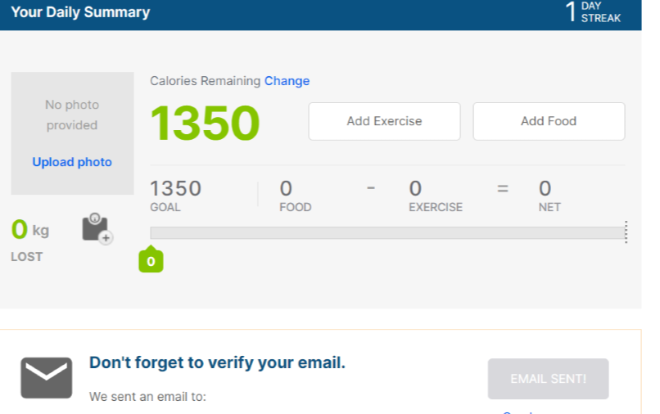

Upon logging in, users are presented with information, including their calorie consumption and expenditure, physical activity logged, and nutritional breakdown. Users are also given two options: add food or add exercise.

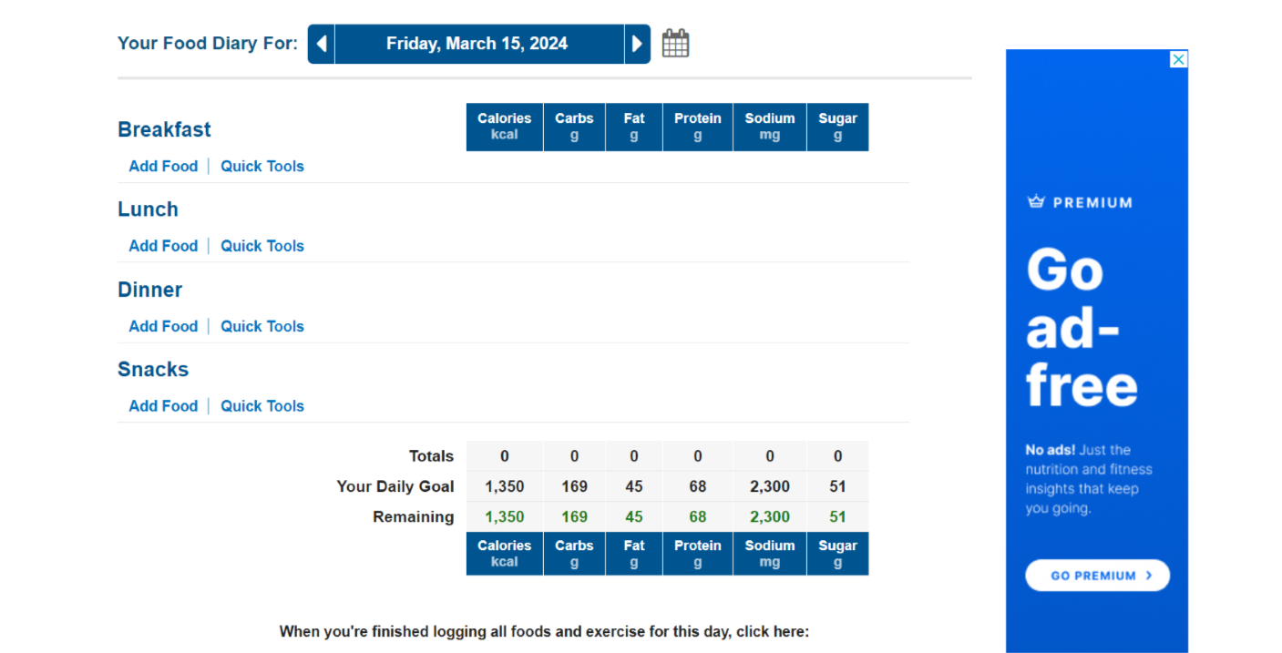

MyFitnessPal's food logging feature provides users with an easy-to-use method to track their dietary intake every day. Users can easily register their meals and snacks by searching for specific foods or scanning the barcodes of products. The app then provides detailed nutritional data for each item of food, including calories, macronutrients (such as protein, carbohydrates, and fat), and micronutrients.

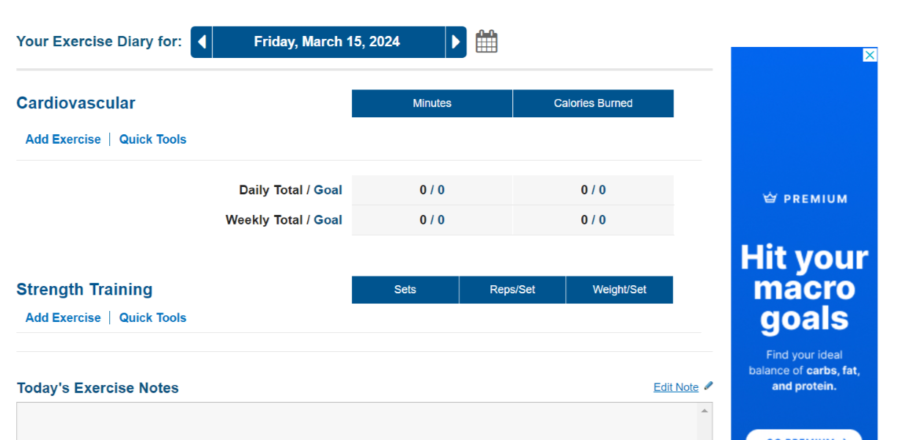

MyFitnessPal's activity tracking feature also allows users to easily track their physical activity and check their progress. With a user-friendly interface, users can log a variety of workouts, such as cardio, weight training, and daily steps. Based on user input, the app then calculates the calories burned during each activity and provides a summary of the user's overall activity level.



Additionally, the app offers a blog featuring a diverse array of articles, recipes and expert advice for users seeking information on topics related to health, fitness, and nutrition. With contributions from fitness professionals and nutritionists the blog provides an educational platform for individuals at every stage of their health and wellness journey. 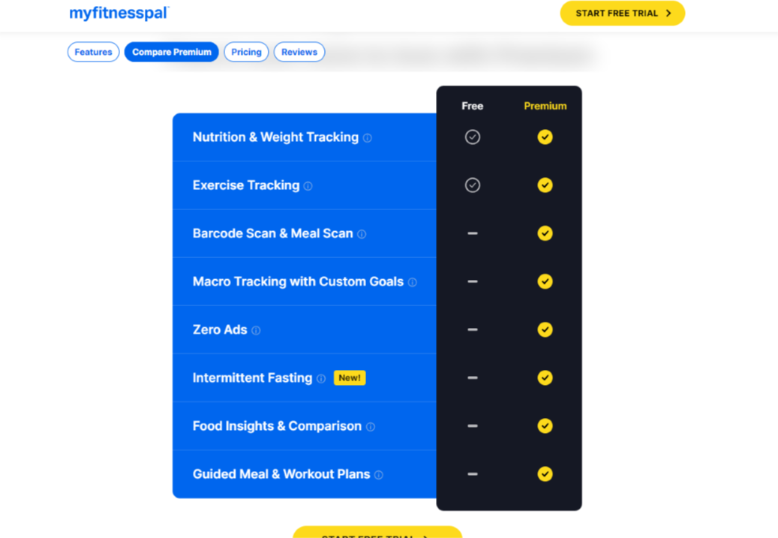

Although most features are accessible to any individual, the app does have a premium plan in which users can pay a fixed price monthly to incorporate more specific features to reach their health goals.

**2.6.2 Fitbit**

Fitbits are wearable gadgets designed to monitor various aspects of physical activity, such as steps taken, the distance travelled, and the number of calories burnt over the day. The Fitbit dashboard functions as a centralized hub which provides an overview of various metrics such as steps taken calories burned, and active minutes.

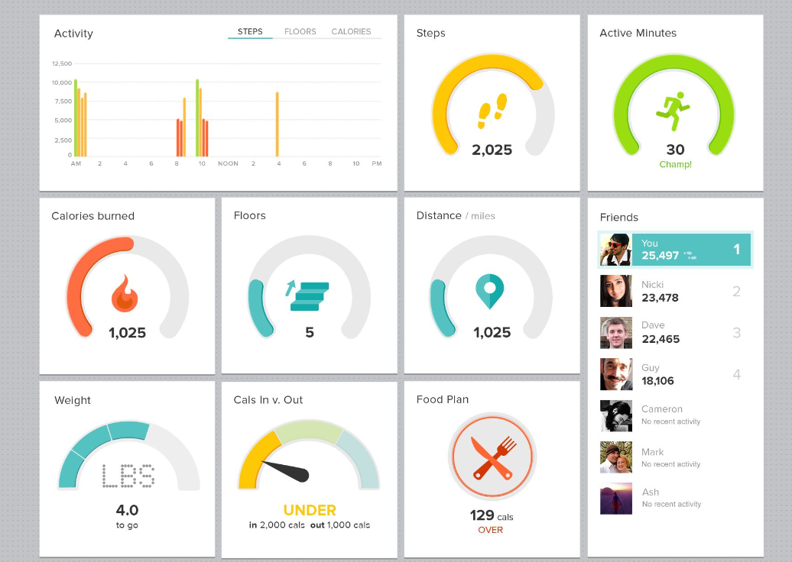

With intuitive graphs and personalized suggestions, the Fitbit dashboard empowers users to make informed decisions about their health. Fitbit also provides features such as guided workouts and personalized coaching to help users stay motivated during their fitness journey.

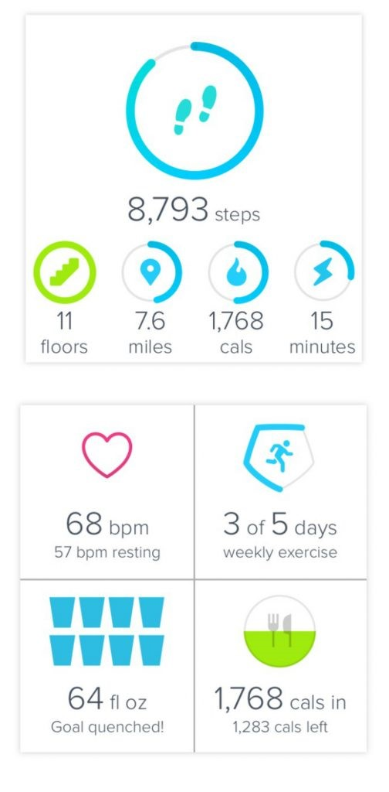

Fitbit also demonstrates a wide range of accessibility features, with both the mobile app and website designed to be user-friendly and accessible to a wide range of users. To assist users with visual impairments, the app and website feature clear and intuitive navigation, with large, easy-to-read text. Fitbit also includes options for altering contrast settings, as well as compatibility for screen readers on both iOS and Android platforms, ensuring that users with disabilities can easily navigate and interact with the application.

**2.6.3 Strava**

Strava is another popular fitness tracking application that caters to runners and cyclists. It provides an extensive range of features to track and monitor physical activity. Strava's platform encourages an active athlete community by allowing users to post their workouts, participate in challenges, and interact with friends and other fellow athletes.

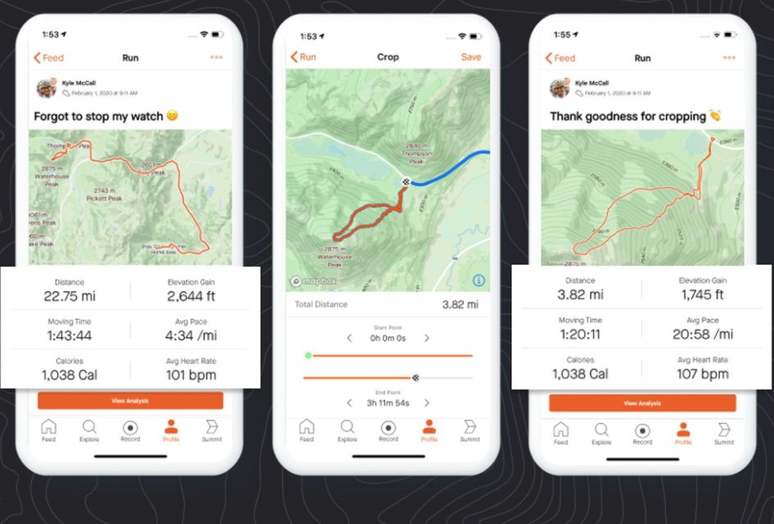

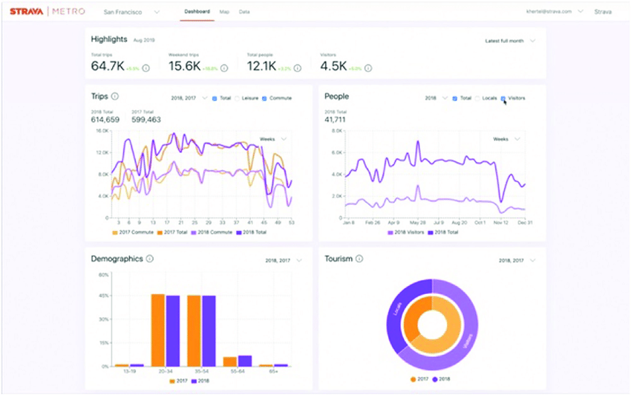

Strava also provides in-depth analytics with graphs and charts, which aid users in measuring their performance and establishing goals during their fitness journey.

Strava's accessibility features offer a clear and intuitive experience for users with easily identifiable buttons and text to facilitate seamless interaction between the user and system. Accessibility features include text size and contrast adjustments, as well as screen reader compatibility, this allows users with disabilities to successfully engage with the app effectively. Furthermore, the app's consistent design patterns and visual cues increase usability, allowing users to easily navigate through various features with ease.

1. Krebs, P. and Duncan, D. T. (2015). Health app use among us mobile phone owners: a national survey. JMIR mHealth and uHealth, 3(4), e101. [Online] [Accessed on 9th February 2024] <https://doi.org/10.2196/mhealth.4924>
2. Arbour, M. W. and Stec, M. A. (2018). Mobile applications for women's health and midwifery care: a pocket reference for the 21st century. Journal of Midwifery &Amp; Women's Health, 63(3), 330-334. [Online] [Accessed on 15th February 2024] <https://doi.org/10.1111/jmwh.12755>
3. Higgins, J. P. T. (2016). Smartphone applications for patients' health and fitness. The American Journal of Medicine, 129(1), 11-19. [Online] [Accessed on 15th February 2024] <https://doi.org/10.1016/j.amjmed.2015.05.038>
4. Litman, L., Rosen, Z., Spierer, D. K., Weinberger-Litman, S. L., Goldschein, A., & Robinson, J. (2015). Mobile exercise apps and increased leisure time exercise activity: a moderated mediation analysis of the role of self-efficacy and barriers. Journal of Medical Internet Research, 17(8), e195. [Online] [Accessed on 15th February 2024] <https://doi.org/10.2196/jmir.4142>
5. Warburton, D. E. R. (2006). Health benefits of physical activity: the evidence. Canadian Medical Association Journal, 174(6), 801-809. [Online] [Accessed on 15th February 2024] <https://doi.org/10.1503/cmaj.051351>
6. Moran, J., Kelly, G., Haberlin, C., Mockler, D., & Broderick, J. (2018). The use of ehealth to promote physical activity in people with mental health conditions: a systematic review. HRB Open Research, 1, 5. [Online] [Accessed on 15th February 2024] <https://doi.org/10.12688/hrbopenres.12796.2>
7. Char, D.S., Abràmoff, M.D. and Feudtner, C. (2020). Identifying Ethical Considerations for Machine Learning Healthcare Applications. *The American Journal of Bioethics*, 20(11), pp.7–17. [Online] [Accessed on 06th March 2024]
8. Sinha, A. and Das, P. (2021). Agile Methodology Vs. Traditional Waterfall SDLC: A case study on Quality Assurance process in Software Industry. [Online] IEEE Xplore. [Accessed on 06th March 2024] <https://doi.org/10.1109/IEMENTech53263.2021.9614779>
9. Raj, P. and Sinha, P. (2020). Project Management in Era Of Agile And Devops Methodologies. *International Journal of Scientific & Technology Research*, 9(1), pp.1024–1033
10. Nielsen, J. (1994). *Usability Engineering*. Amsterdam: Morgan Kaufmann
11. ‌WCAG. (n.d.). Web Content Accessibility Guidelines: Conformance Resources. [Online] [Accessed on 07th March 2024] <https://wcag.com/>
12. STINE, R. (1989). An Introduction to Bootstrap Methods. *Sociological Methods & Research*, 18(2-3), pp.243–291 [Online] [Accessed on 07th March 2024] <https://doi.org/10.1177/0049124189018002003>
13. ‌ Shaw, R.J., Horvath, M.M., Leonard, D., Ferranti, J.M. and Johnson, C.M. (2015). Developing a user-friendly interface for a self-service healthcare research portal: cost-effective usability testing. *Health Systems*, 4(2), pp.151–158. [Online] [Accessed on 07th March 2024] <https://doi.org/10.1057/hs.2014.26>
14. ‌*Dutta, M.J. (2007). Communicating About Culture and Health: Theorizing Culture-Centered and Cultural Sensitivity Approaches. Communication Theory, 17(3), pp.304–328*. [Online] [Accessed on 07th March 2024] <https://doi.org/10.1111/j.1468-2885.2007.00297.x>
15. ‌ Goeree, R., He, J., O’Reilly, D., Tarride, J.-E., Xie, F. and Burke (2011). Transferability of health technology assessments and economic evaluations: a systematic review of approaches for assessment and application. *ClinicoEconomics and Outcomes Research*, p.89. [Online] [Accessed on 07th March 2024] <https://doi.org/10.2147/ceor.s14404>
16. ‌ Giebel, G.D., Speckemeier, C., Abels, C., Plescher, F., Börchers, K., Wasem, J., Blase, N. and Neusser, S. (2023). Problems and Barriers Related to the Use of Digital Health Applications: Scoping Review. *Journal of Medical Internet Research*, [Online] [Accessed on 07th March 2024] 25, p.e43808. <https://doi.org/10.2196/43808>
17. Pradal-Cano, L., Lozano-Ruiz, C., Pereyra-Rodríguez, J.J., Saigí-Rubió, F., Bach-Faig, A., Esquius, L., Medina, F.X. and Aguilar-Martínez, A. (2020). Using mobile applications to increase physical activity: a systematic review. *International Journal of Environmental Research and Public Health*, 17(21), p.8238. [Online] [Accessed on 07th March 2024] <https://doi.org/10.3390/ijerph17218238>
18. ‌Punukollu, M. and Marques, M. (2019). Use of mobile apps and technologies in child and adolescent mental health: a systematic review. *Evidence Based Mental Health*, 22(4), pp.161–166. [Online] [Accessed on 12th March 2024] <https://doi.org/10.1136/ebmental-2019-300093>
19. Milne-Ives, M., Lam, C., De Cock, C., Van Velthoven, M.H. and Meinert, E. (2019). Mobile apps for health behaviour change in physical activity, diet, drug and alcohol use, and mental health: a systematic review (Preprint). *JMIR mHealth and uHealth*, 8(3). [Online] [Accessed on 13th March 2024] <https://doi.org/10.2196/17046>
20. ‌ H Fang, P., Shi, S., Menhas, R., Laar, R., & Saeed, M. (2022). Demographic characteristics and digital platforms for physical activity among the chinese residents during the covid-19 pandemic: a mediating analysis. Journal of Multidisciplinary Healthcare, Volume 15, 515-529. [Online] [Accessed on 13th March 2024] <https://doi.org/10.2147/jmdh.s354984>
21. Passalent, L., Cyr, A., Jurišica, I., Mathur, S., Inman, R. D., & Haroon, N. (2021). Motivators, barriers, and opportunity for e‐health to encourage physical activity in axial spondyloarthritis: a qualitative descriptive study. Arthritis Care &Amp; Research, 74(1), 50-58. [Online] [Accessed on 13th March 2024] <https://doi.org/10.1002/acr.24788>
22. The Be Well Collective. (n.d.). *Are Health Apps Exacerbating Our Health Problems?* [online] Available at: <https://bewellcollective.co.uk/blog/are-health-apps-exacerbating-our-health-problems>
23. ‌Mustafa, A.S., Ali, N., Dhillon, J.S., Alkawsi, G. and Baashar, Y. (2022). User Engagement and Abandonment of mHealth: A Cross-Sectional Survey. Healthcare, 10(2), p.221. [Online] [Accessed on 14th March 2024] <https://doi.org/10.3390/healthcare10020221>
24. Liu, P., Astudillo, K., Velez, D., Kelley, L., Cobbs-Lomax, D. and Spatz, E.S. (2019). Use of mobile health apps in low-income populations: a prospective study of facilitators and barriers. p 11. [Online] [Accessed on 14th March 2024] <https://doi.org/10.1101/2019.12.22.19015636>
25. ‌Hengst, T.M., Lechner, L., Dohmen, D. and Bolman, C.A. (2023). The facilitators and barriers of mHealth adoption and use among people with a low socio-economic position: A scoping review. *Digital Health*, 9, p.20552076231198702. [Online] [Accessed on 14th March 2024] <https://doi.org/10.1177/20552076231198702>
26. Pradal-Cano, L., Lozano-Ruiz, C., Pereyra-Rodríguez, J.J., Saigí-Rubió, F., Bach-Faig, A., Esquius, L., Medina, F.X. and Aguilar-Martínez, A. (2020). Using mobile applications to increase physical activity: a systematic review. *International Journal of Environmental Research and Public Health*, [online] 17(21), p.8238. [Online] [Accessed on 14th March 2024] <https://doi.org/10.3390/ijerph17218238>
27. MyFitnessPal (2022). *MyFitnessPal*. [Online] [Accessed on 1st April 2024] Available at: <https://www.myfitnesspal.com/>.
28. ‌ Staff, F. (2014). Fitbit Blog. [Online] [Accessed on 1st April 2024] Available at: <https://blog.fitbit.com/fitbit-dashboard-updated-with-weekly-activity-and-more/>
29. Situated data analysis: a new method for analyzing encoded power relationships in social media platforms and apps - Scientific Figure on ResearchGate. [Accessed 2 April 2024] Available at: <https://www.researchgate.net/figure/A-screenshot-of-the-Strava-Metro-dashboard-for-San-Francisco-as-shown-in-a-demo-video_fig6_342235253>
30. Benedict, T. (2020). *Strava (finally) lets you edit ride activities on mobile app, plus other updates*. Bikerumor. [Accessed on 2nd April 2024] [Online] Available at: <https://bikerumor.com/strava-finally-lets-you-edit-routes-on-mobile-app-plus-other-updates/>